**Basic 3D Graphics in Processing - Assignment**

**Carson Foster**

1. 3D Snowman

Your first assignment is to create a snowman in Processing (in 3D, of course). It must have a body, eyes, a mouth, and arms.

Hint: you can use spheres of different colors for the body, eyes, and mouth. You might also want to use some lighting to make it look more realistic.

Solution

The only parts of the following code that might be confusing are the long computations for two fingers. Don’t mind that – I did some trigonometry to make sure that the angles between the arm and the fingers were the same, and that each finger had the same length. You can just eyeball it if you want. Here’s what the output looks like:

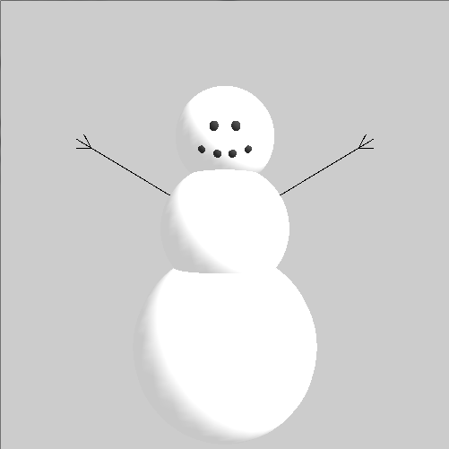



1. Final Exam

This is it, the final assignment of the course: decide on a project (that must incorporate 3D elements), and make it. You can do it!

Some possible ideas are: 3D Pong, first-person puzzle game, third-person horror game, 3D art displays, etc.

Solution

There’s no solution! Go at it until you finish.